Test Report
  - 7595 Microcontroller Routine Execution and Overhead Test (Design Development)
Tested By: | Lucas Swartz, Runil Daptardar
Test Pass/Fail | Pass

Detailed Beckett Test Procedure

Test Procedure Name: TP-096 Microcontroller Routine Execution and Overhead Test, Rev 4.

Test Procedure Guidelines or References:

Ganssle, Jack. “The Art of Designing Embedded Systems”. Pages 79–83

ES-0175, Software Specification, Revision B; As of 6/11/2026

ES-0176 Communication Specification, Revision B; As of 6/15/2026

ES-0178 BLE Service Specification, Revision B; As of 5/4/2026

Previous Test: TR-3971 Microcontroller Routine Execution and Overhead Test

Micro I/O Test: TR-3855 Micro I-O Signal Test

Objective(s):

Measure, record and analyze the execution time and overhead of the main program loop, idle loop, all ISR’s, all subroutines that disable interrupts, and all other major sub-routines, as applicable.

Device(s) Tested

One 7595 GeniSys 2.0 Primary Control

Acceptance Criteria

General

All interrupt timing latencies must be within a period that will allow them to function properly.

For devices that write to FLASH during normal operation, proper shutdown time must not exceed the shortest determined hold-up time when power is removed. Proper shutdown is defined as all operations, including all flash operations, that must take place for the device to return to a nominal state have been performed.

Chief Engineer of the product must approve proper shutdown time that exceeds 85% of the shortest determined hold-up time.

There must be no other software timing conflicts identified.

Test Procedure Summary

Modify the DUT’s software as follows: near the beginning of a routine, set a debug output bit high. Just before exiting the routine, return the bit to a zero. Put an oscilloscope probe on the output bit. Record the maximum and minimum routine execution times and overhead percentages. Repeat for main program loop, idle loop, all ISR’s, all subroutines that disable interrupts, and other major subroutines as applicable.

Test Parameters

Input Voltage: Wall power to Isolating Transformer to Variac. The Variac was adjusted to that T1’s secondary voltage was measured to be 24.27±0.10VAC when in its minimally loaded state (Standby with all inputs switched open). This is the minimum input voltage value that accounts for worst-case rated input voltage and T1 output tolerance.

IoT module installed (except where noted).

AUX switch closed.

Timing Captures: Multiple iterations of each timing were observed and a scope capture that represented close to the maximum timing was captured.

Unless otherwise noted, each test was conducted with the unit in Standby mode.

Results

Acceptance criteria were met. Per 4.1.2., Chief Engineer approval was required because proper shutdown time was 96.9% of measured hold-up time.

Test Conclusions

Following in the remainder of section 7.1 are more detailed conclusions on specific areas.

Interrupts:

Most interrupts consume very little of the processor’s time and do not significantly contribute to variability in the timing of non-interrupt code. The SysTick, TIM1, TIM16, interrupts require mere microseconds of time to execute, so even with the 1kHz frequency of SysTick, none of these interrupts use even two-tenths of a percent of the processor’s execution time.

TIM17 uses 6.4% of processor time; it fires at 2kHz and runs a 3-time loop each time it executes.

Note that when calculating maximum times for other combinations of code to execute, this interrupt runs so frequently that any observed measurement of a chunk of code taking 1ms or more to execute is already assumed to include the extra time taken for TIM17 interrupts to execute.

ADC1 uses 4.4% of processor time. It fires in bursts of 4 at a burst-to-burst frequency of 2kHz. Most of those execute very fast, on the scale of one or two microseconds since they just read one 16-bit value and store it in memory. The final interrupt takes somewhat longer; around 10.6 microseconds.

For reference, in the previous test the ADC1 Interrupt boasted a large 14.5% of processor time. This was lowered due to new handling of power loss detection, by removing the detection and reporting form ADC1 into the main loop.

The test procedure was also adjusted in this report for a more accurate result, which shortened times by increasing the scale of the pulse when measuring area. While this did not have as big an impact on the time as 7.1.2.3.1, when tested on the commit from TR-3971 the percent processor time on the previous test was lowered to 13.4%.

See section 7.1.2.2.1, but for ADC1 interrupts instead of TIM17 interrupts.

USART2 uses 0.126% of processor time. It fires in a split burst 8 request interrupts and 17 response interrupts, making the total burst each execution 25 pulses long.

This value is much less than in the last report which showed an average duty cycle of 0.885%. This is because area and high are taken on much smaller scales as compared to the old method, making the data more accurate by cutting out the noise between pulses that would otherwise add to the area measurement on the oscilloscope. The new method was also tested on the commit from TR-3971, showing an average percent processor time of 0.116%.

I²C uses 1.5% of processor time. It fires in bursts of at minimum 4 and vary depending on the number of bytes to be sent and received. The first two and last are slightly longer; about 5-9 microseconds. While the center ones vary in quantity but always take roughly 3.8 microseconds.
        - During the controller’s execution the accelerometer alternates between two states. It spends 79.55% of the time in the first state, Accel_Read_num_Unread. This is a detection state waiting for bytes to be transferred from I²C, meaning that the interrupt rarely fires and only takes up 0.84% of the controller execution time. Then, it spends the remaining 20.45% of the time in the Accel_Read_Samples state, where it actively reads data from the accelerometer in one-byte chunks by firing the I²C. This forces the I²C interrupt to be called far more often making it use 2.95% of the processor time. It is these two states together that make up the 1.5% processor time that the I²C takes overall.

Watchdog Timers:

The WDT is set to restart the system if it’s not reset within 2.048 seconds. The closest the execution comes to tripping the WDT is when transitioning from bootloader to firmware. The time it took from bootloader’s WDT Init to bootloader’s end was at max 8.3ms and from firmware’s start to the first firmware WDT Reset was 28.3ms, meaning the total time between watchdog resets was a maximum of 36.6ms.

This is much shorter than the previous version of the test as the closest the code came to tripping the WDT is during Cylon-ing, which took 870ms, leading to a total time between when the firmware starts executing and when it first resets WDT of 913ms. That code was altered and now the Cylon sequence is handled in the main loop within HandleStatusLights()

Main Loop:

Some time-sensitive tasks are taken care of in the main loop, so if the main loop ever takes too long, the code would not be able to service those tasks. Generally, the main loop executes at a fairly consistent 1.08ms, never getting above 2ms, except in response to specific events.

Additionally, the main loop may erase one flash page during its execution. This test measured a maximum page erase time of 22.98ms, although documentation suggests assuming a maximum erase time of 40ms. These erases may only occur in the main loops immediately following one or more flash writes and cannot happen for the same flash stack back-to-back but must wait until the new page becomes mostly full again. This suggests at most 4 loops in a row can have a page erase, and then some time must pass before this occurs again.

Subtracting the percentage of time consumed by all interrupts (approx. 12.5%) from the standard main loop time (1.1ms) shows that a single normal iteration of the main loop requires 0.962ms of processor time to perform all of its duties.

For reference, in the previous test (TR-3971), that version of the code exhibited a normal main loop time of 1.3ms and total time spent in interrupts of 21%; a single normal iteration of the main loop required 1.027ms of processor time.

Power Loss Detection

The code’s power loss detection methods involve analyzing a filled buffer of datapoints. The buffer fills at a fixed rate and is only analyzed when it’s full. This means the points in time where the code can detect power loss occur at fixed intervals, and the length of these intervals is the maximum amount of time it might take us to detect a loss of power. Measurements indicate this delay can be as long as 61.23ms in Standby and 51.0ms in run.

This detection now occurs in the main loop, so it is very quick to call for an abort, but there is still some delay between the time power loss is detected and when it calls for the cycle to abort. Measurements indicate that this additional delay can be as long as 0.193ms.

For reference, in the previous test (TR-3971), the call to abort the cycle was not embedded into the main loop but into the ADC1 Interrupt. That version of the code exhibited a delay as long as 16.09ms.

Flash Writes on Power Loss

The delay between non-interrupt code querying power loss and actually writing out all necessary information to flash memory is satisfactory, measured as no more than 1ms, indicating it only takes one main-loop iteration to accomplish.

Power Loss to Flash Writes

On power loss, the main concern is having enough time to write all of the required information to flash before the MCU does not have enough power to guarantee operation (holdup time). Henceforth, this is referred to as proper shutdown.

Per TR-3855, the adjusted minimum measured holdup time was 92.86ms. The maximum measured proper shutdown time was 51.90ms.

Computing the worst-case scenario proper shutdown time from measured values, we get 51.0 + 0.193 + 22.98 + 0.812 = 74.99ms, which is calculated as the sum of the following values:

Maximum Power Loss Detection Time in Run (51.0ms) – see 7.1.5.1

Maximum Power Loss Detection to Cycle Abort (0.193ms) – see column C, worksheet “PowerLoss”, in accompanying spreadsheet TR-4076 - Calculations.xlsx

Maximum Flash Page Erase Time (22.98ms) – see 7.1.4.2. This can only happen when initiated prior to Power Loss Detection

Maximum Cycle Abort to Flash Write End Time (0.812ms) – see 7.1.6.1

Theoretical worse-case scenario is 51.0 + 0.193 + 40.00 + 0.812 = 90.005ms which replaces the measured maximum flash page erase time with the theoretical maximum flash page erase time. This time is below the minimum measured holdup time by 2.86ms and is fast enough to properly shut down under the worst-case scenario.

Test Results Summary

Cells with values in italics indicate a value that was computed separately, from recorded data. Otherwise, normal text indicates a value that was recorded directly, either by the oscilloscope’s measuring functionality or manually. Computations recorded in accompanying spreadsheet TR-4076 Calculations.xlsx.

For additional information on an individual test, see its corresponding subsection in section 8.14; subsection number is given by the Index column.

Index | Description |  | GitLab Pipeline IID | Commit | Duration |  |  |  |  | (Mean) Freq. (Hz) | Period | Unit | % Processor Time
 |  |  |  |  | Mean | Unit | Std. Dev. | Min. | Max.
Power Loss, Flash Writes, Holdup Time
1 | Power Loss to Loss Detection |  | #5409 | 213f9124
 | Standby |  |  |  | 53.88 | ms | 5.568 | 44.73 | 61.23
 | Run |  |  |  | 37.97 | ms | 5.531 | 30.26 | 51.00
2 | Power Loss to Cycle Abort |  | #5409 | 213f9124 | 38.10 | ms | 5.535 | 30.39 | 51.12
3 | Power Loss to Completion of Flash Writes |  | #5409 | 213f9124 | 38.86 | ms | 5.536 | 31.17 | 51.90
4 | Power Loss Detection to Completion of Flash Write |  | #5409 | 213f9124 | 0.896 | ms | 0.028 | 0.827 | 0.949
5 | Cycle Abort to Completion of Flash Writes |  | #5409 | 213f9124 | 0.768 | ms | 0.030 | 0.720 | 0.812
Main Loop
6 | Main Loop |  | #5377 | e7c2296d | 1.081 | ms | 0.130 | 0.5528 | 1.818
7 | Maintain Safety |  | #5348 | 0161deb4d | 679.8 | μs | 34.33 | 654.2 | 804.1
8 | CRC-32 Full Check |  | #5349 | d9001acdb | 512.3 | ms | 0.236 | 512.1 | 512.8
9 | Serial Comms (Get Advert. Data) |  | #5350 | 1b2bd8269 | 84.80 | μs | 33.67 | 76.990 | 144 | 9.994
Interrupts
10 | SysTick Interrupt |  | #5352 | 31366111c | 1.062 | μs | <0.001 | 1.061 | 1.063 | 1001 | 0.999 | ms | 0.106%
11 | ADC1, Single Sample |  | #5353 | 8f30adb3 | 1.621 | μs | <0.001 | 1.612 | 1.639
12 | ADC1, First Sample to Sampling Done |  | 5354 | f8e70d9c | 47.23 | μs | 9.922 | 3.198 | 86.61
13 | ADC1, Scan Done |  | #5355 | c051ee0c | 7.490 | μs | 0.880 | 0.994 | 8.037
14 | ADC1, Whole Interrupt |  | #5356 | b6c6dd7f |  |  |  |  |  |  |  |  | 4.359%
15 | TIM17 Interrupt |  | #5357 | 4107e792
 | Standby |  |  |  | 32.42 | µs | 2.405 | 31.04 | 47.94 | 2003 | 499.9 | µs | 6.494%
 | Run |  |  |  | 31.84 | µs | 2.277 | 29.69 | 45.26 | 2003 | 499.2 | µs | 6.378%
16 | TIM16 Interrupt |  | #5358 | 2ddbf648 | 2.433 | µs | 824.6 | 2.432 | 2.435 | 9.989 | 100.1 | ms | 0.002%
17 | USART2 Interrupt |  | #5360 | 1e0ea204 | 4.906 | µs | 0.108 | 4.426 | 5.239 |  | 100.1 | ms | 0.126%
18 | TIM1 Interrupt |  | #5361 | 73b495a4 | 3.247 | µs | 22.30 | 3.181 | 3.308 | 100.3 | 9.972 | ms | 0.033%
19 | I²C Interrupt |  | #5412 | 834a8576 | 4.630 | µs | 0.709 | 3.869 | 9.049
22 | I²C Overall Duty Cycle |  | #5404 | d70c46ad |  |  |  |  |  |  |  |  | 1.498%
Startup
23 | Flash Check |  | #5362 | 293944e5 | 3.998 | ms | 0.003 | 3.994 | 4.005
24 | Firmware Start to First Firmware WDT Reset |  | #5363 | 92c2a38d | 28.27 | ms | 4.128 | 28.26 | 28.27
25 | Bootloader WDT Init to Bootloader End |  | #5378 | 0143d3bb | 8.291 | ms | <0.001 | 8.290 | 8.292
26 | Cylon |  | #5365 | aa0d773d | 944.1 | ms | 460.1 | 943.4 | 944.5
27 | Power-On to Entering Standby |  | #5367 | 4afb9eef | 1.068 | s | 0.003 | 1.064 | 1.071
28 | Time in Reset |  | #5366 | e868321c | 984.2 | ms | 0.158 | 984.0 | 984.6
29 | ADC Calibration |  | #5411 | 5aae013d | 30.47 | µs | 0.007 | 30.46 | 30.48
Communication
30 | Field Configuration Write |  | #5308 | 4714ef2f | 1.470 | ms | 0.011 | 1.450 | 1.480
31 | Field Configuration Read |  | #5368 | afb6907bd | 142.4 | µs | 28.31 | 119.5 | 186.1
32 | Maximum Modbus Timing (Gather Report Data) |  | #5382 | bbd89349 |  | µs |  |  | 561.5
Accelerometer
33 | Read WhoAmI |  | #5394 | adfc597b | 1.927 | ms | <0.001 | 1.926 | 1.928
34 | Write Configuration |  | #5395 | c51512ce | 5.872 | ms | 0.004 | 5.866 | 5.877
35 | Read Num Unread |  | #5396 | 83fa41b5 |  | ms |  | 1.638 | 28.82
36 | Read Samples |  | #5397 | e0c5aa12 | 2.083 | ms | 0.486 | 2.083 | 3.348
Bootloader
37 | Bootloader Main Loop |  | #5368 | 96fa2659 | 32.32 | µs | 4.888 | 31.16 | 50.72
Interrupts Disabled
38 | TIM17 Interrupt Disabling — HandleAC_Inputs() |  | #5383 | ff8354a1
 | Outside |  |  |  | 9.717 | µs | 2.752 | 8.786 | 48.75
 | Inside |  |  |  | 8.301 | µs | 2.747 | 7.103 | 20.96
31 | Flame Sensing State - Timings |  | #5371 | 2aabe9ea
 | Flame Inactive | Discharging |  |  | 2.014 | ms | 101.0 | 1.974 | 2.494 | 1.992
 |  | Sensing |  |  | 500.1 | ms | 704.9 | 498.9 | 501.4
 | Flame Active | Discharging |  |  | 1.994 | ms | 5.730 | 1.981 | 2.010 | 13.25
 |  | Sensing |  |  | 73.50 | ms | 246.5 | 73.3 | 73.86
40 | TIM17 Interrupt Disabling — HandleLinePower() |  | #5372 | a7bd9325
 | Outside |  |  |  | 94.37 | µs | 4.842 | 89.43 | 124.8
 | Inside |  |  |  | 97.42 | µs | 6.926 | 92.43 | 127.9
Motor Control
41 | MotorChargeCap() |  | #5373 | 113bfae4 | 389.6 | µs | 27.20 | 320.8 | 440.2
42 | Safety Relay & Motor timings |  | #5375 | d440bec8
 | Safety Relay On to Motor Relay On |  |  |  | 194.4 | ms | 4.835 | 184.2 | 200.1
 | Safety Relay Off to Motor Relay Off |  |  |  | 95.97 | ms | 3.732 | 90.22 | 100.6
Flash Erasing
43 | Flash Page Erasure |  | #5381 | f160a7ce | 22.92 | ms | 0.025 | 22.89 | 22.98
44 | Bootloader Firmware Flash Erasure |  | #5376 | ef9612e0 | 395.6 | ms | 0.117 | 395.4 | 395.8
45 | Bootloader OTA Block Writing |  | #5376 | ef9612e0 | 40.89 | µs | 0.473 | 40.47 | 43.67

Details of How the Test Was Performed

Software modifications:

A new git branch, testing/20260528-routine-timing was created to track all of the changes for this new test.

An initial commit 65ca0c15 was created with a baseline modification shared by all tests: the Gitlab CI/CD YAML file was modified to call script CompleteBuild.ps1 with the -EnableTestpoints switch set, which would cause build pipelines to create a hex file that could be used for running the test. Although most tests were run with a local build, this allowed re-testing or test verification to be done very quickly.

Each instance of modified code was built using the standard production build script CompleteBuild.ps1, with the -EnableTestpoints switch set.

For each commit used in a test, a pipeline was run on GitLab which would build an image that would be usable for the test, which could be re-used later. The pipeline IID (used for the build number) was noted along with the commit hash.

After each test, source code modifications were reverted, and a revert-commit made before the next set of modifications were made.

When all tests were completed, the tip of the branch was tagged as testing/20260528-routine-timing to keep a permanent record of the test cases.

Hardware modifications:

A yellow and blue wire were soldered-onto designated BLU and YLW pads of the controller board (this requires scraping off solder mask from these pads).

Image of that modification:
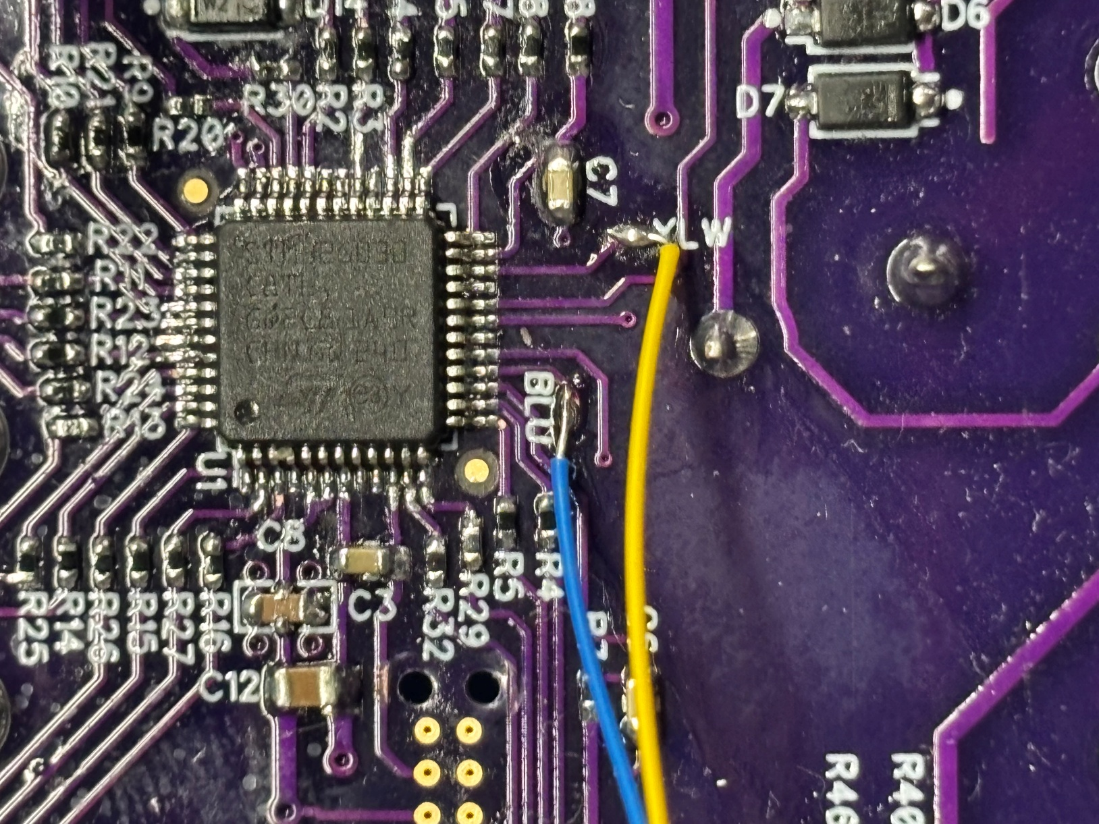

A new cable was made with exposed wires to connect in series with the 120V AC input, for the power detection tests (8.12.1–8.12.5, 8.14.27 for further details)

Image of that modification:
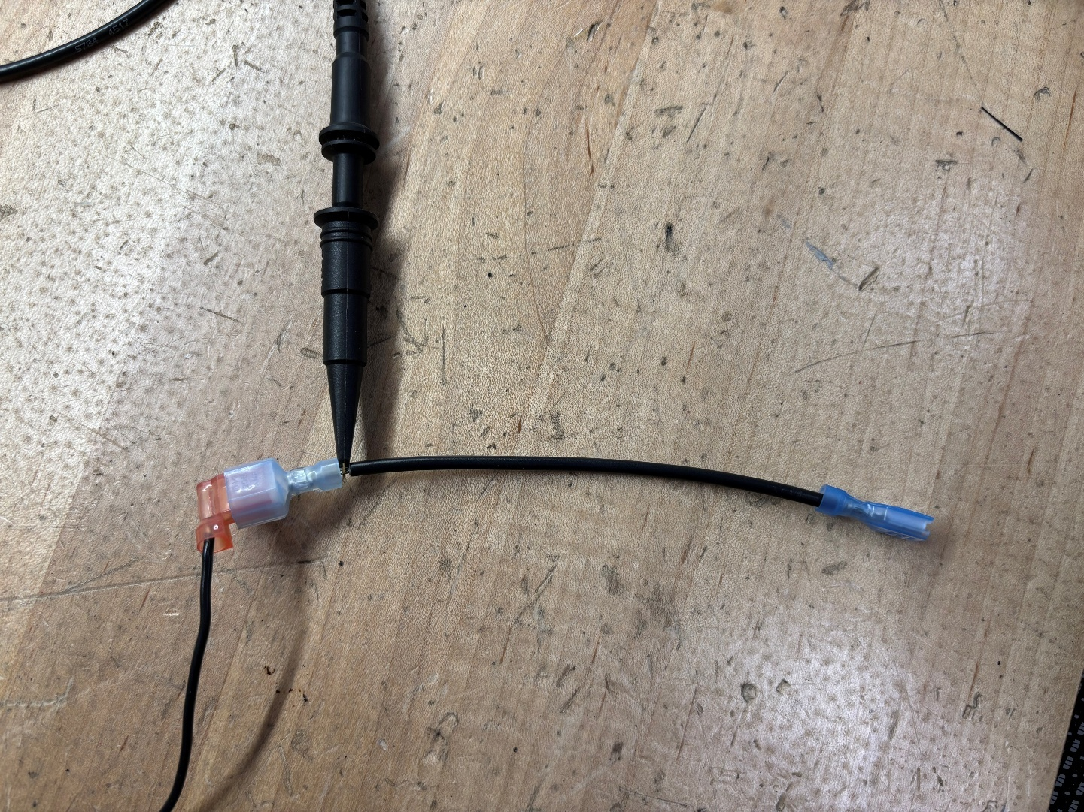

A breadboard module was made with an accelerometer to be connected to the DFS port as the first test GeniSys did not have a built in one. (only used for tests using the initial GeniSys controller)

Image of that modification:
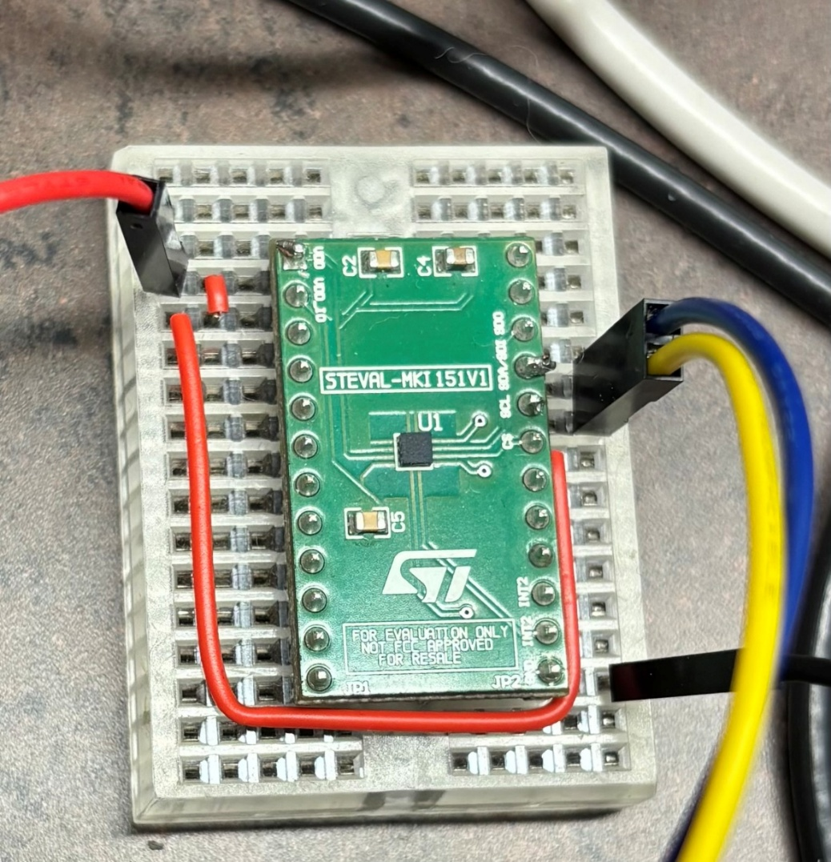

All connectors from the demobox connected to the DUT.

A USB-to-serial adapter and an IoT adapter card were attached to flash new images onto the DUT for each test, then swapped with an IoT card before starting each test.

The A/C power plug of the demobox was connected to one of the six outlets of a power strip.

A 3-prong power cable with bare, stripped ends was plugged into another outlet of the power strip. (Only used during power loss and detection testing in laboratory)

The power strip was plugged into a Variac.

The Variac was connected to an isolation transformer.

The isolation transformer was connected to facility’s mains power.

Before each test, the Variac was adjusted until a multimeter set to measure RMS A/C voltage across DUT’s Tr and Tc matched the voltage indicated in section 6.1.

Four probes were connected to the oscilloscope, connected in the following way:

Channel 1 (Yellow) was connected to the yellow wire, a grounding clip attached and connected to the Tc terminal on the front of the DUT. Vertical scale was set to 1V per division.

Channel 2 (Blue) was connected to the blue wire. Vertical scale was set to 1V per division.

Channel 3 was connected to the exposed wires shown in 8.2.2. Channel 3 was never directly displayed during any test.

Channel 4 was connected to the hot wire of the power cable from 8.6. Channel 4 was never directly displayed during any test.

Test Assembly set-up:

Image of test setup at desk:

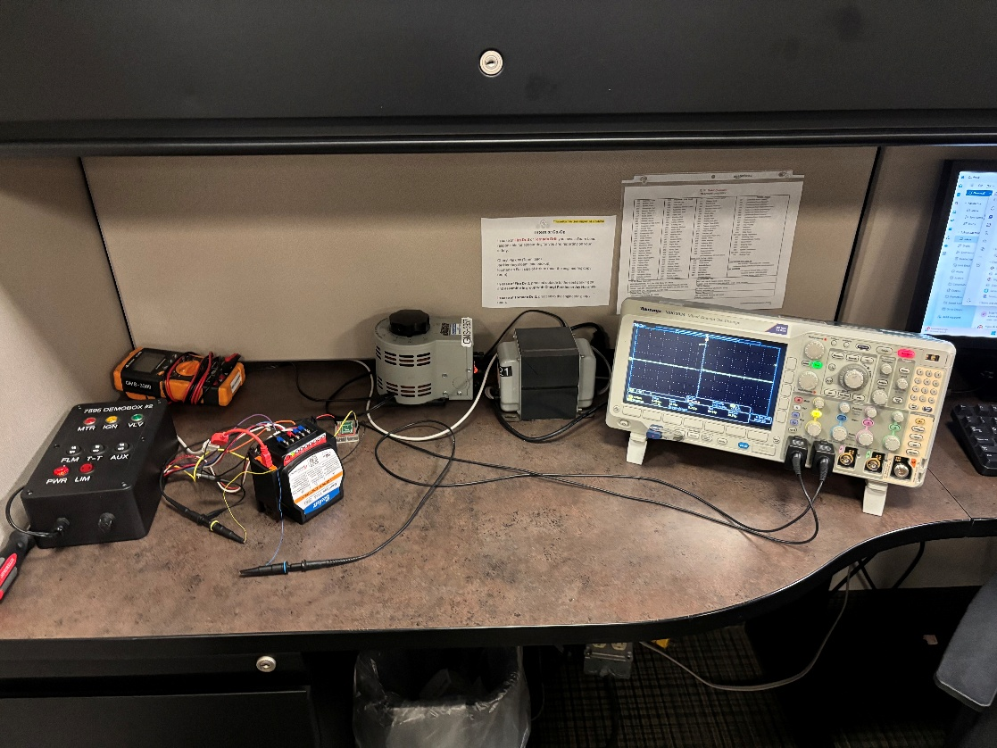

Desk testing setup was used for majority of Timing tests as it allowed easy access to a desktop computer.

Image of test setup in lab:

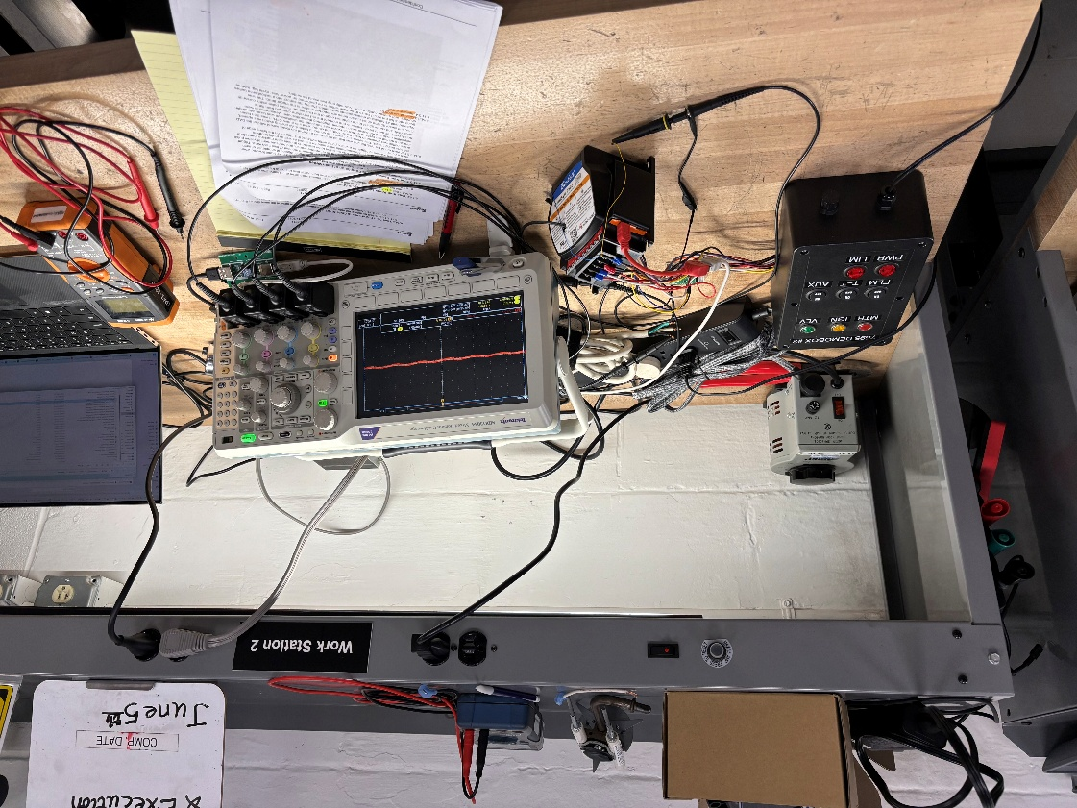

Lab test setup was used for sections 8.14.1 - 8.14.5 (Power Loss tests), and 8.14.27 (Power On to Entering Standby), as they required connecting and reading directly from the A/C power plug in 8.6. To do this at a desk is in violation of rules regarding Co-Op health and safety.

Close-up of DUT wire setup (same when in casing):

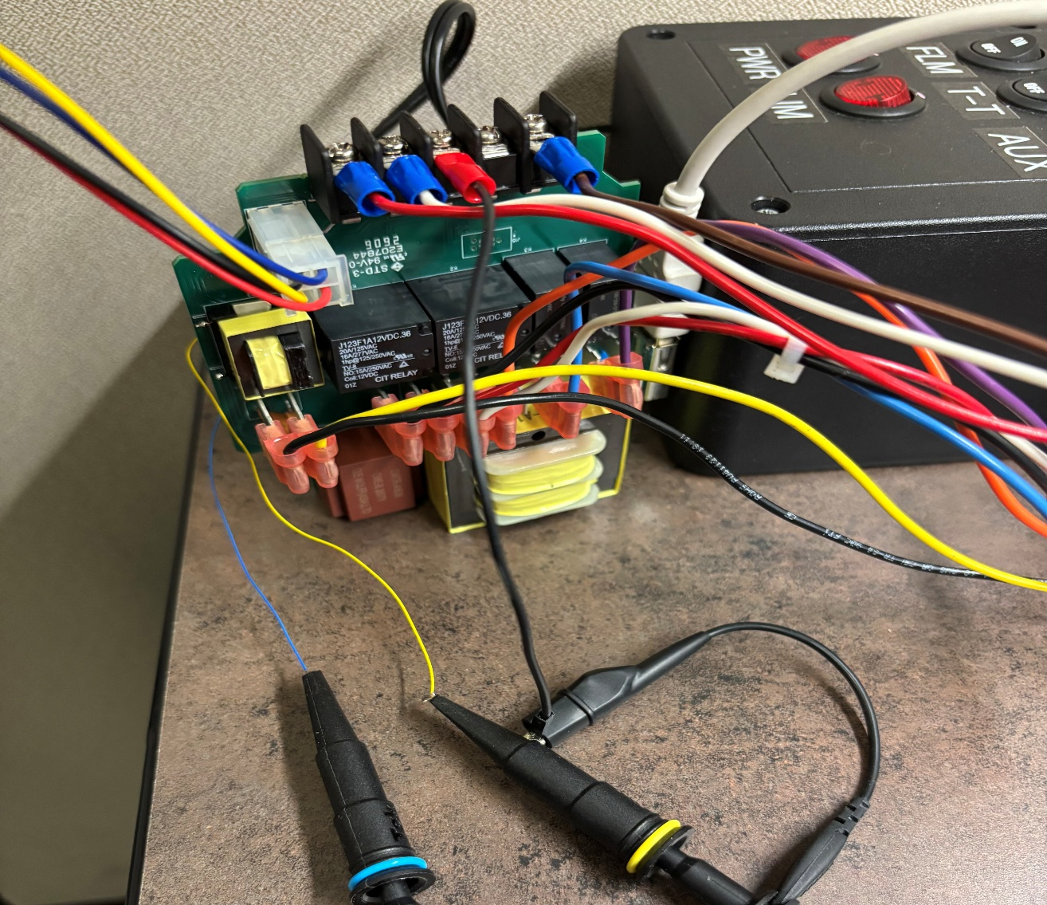

Oscilloscope configuration:

A Math waveform was defined, showing the (Ch3 – Ch4), which shows the hot line of the Genisys AC input relative to the hot line of the Demobox’s AC input. The Math waveform was not displayed except when power loss times needed to be determined. Vertical scale was set to 50V per division. When displayed, it is shown as a red waveform. Due to the way the waveform is defined, it is normally 0V when the GeniSys is powered, but near-instantly becomes a sine wave when power to the GeniSys is cut off from within the Demobox. This provides a reliable, consistent means of determining power loss during testing.

Oscilloscope further configured as indicated in section 8.14 for each test.

Assume the following oscilloscope trigger configurations, unless otherwise noted:

Yellow signal is used for triggering.

Whichever signal is used for triggering, assume trigger on rising edge.

If triggering on pulse width, assume triggering on high pulse width.

“Positive” and “Negative” in the context of digital-signal waveforms are synonymous with “High” and “Low”.

Individual Test Descriptions:

Time from Power Loss to Power Loss Detection

Yellow signal raised when power loss first detected in ISR. Otherwise see 8.14.3 for details. 10 individual runs taken during a Standby state. Later, measurements from 8.14.3 were used to derive this time from measurements taken in a Run state, see that section for details; time was determined by subtracting time from trigger to cursor ⓑ from time from cursor ⓐ to cursor ⓑ.

Commit: 213f9124

Pipeline: #5409

Time from Power Loss to Cycle Abort

See 8.14.3 for details; but note that these measurements were taken at the same time as that test, and not 8.14.1. Value determined by taking the time from power loss relative to trigger.

Commit: 213f9124

Pipeline: #5409

Time from Power Loss to Completion of Flash Writes

Yellow signal went high when power loss was first detected in an ISR; yellow signal lowered when ShouldAbortCycle()’s return-true branch was taken. Blue signal toggled at completion of each flash write. Cursors used to determine moment of power loss and moment of final flash write. Trigger time was on ShouldAbortCycle() entering its return-true branch, and measurement of yellow pulse width provided extra time for power loss detection to be reacted-to in main state machine (henceforth referred to as “cycle abort”). Measurements were used for this test as well as multiple others. Oscilloscope was set to trigger on a yellow pulse width >20.0μs; this triggers on the falling edge of such a pulse.

For each run of the test, the unit was first taken through a normal run cycle, flipping the FLM switch before it exited pre-purge. This eventually caused the control to soft lockout. The AUX switch was opened, action button was pressed to reset the lockout, and control went into a new CFH. It was then taken through a normal run cycle, and once carryover was complete, the oscilloscope was taken into single-acquisition mode and the power switch opened, triggering the oscilloscope. Measurements were noted; cursor ⓐ set to power loss time (the moment the red waveform changed from flat to sinusoidal), and cursor ⓑ set to the rightmost edge of the blue signal. Yellow pulse width, cursor ⓐ time, and cursor ⓑ time noted (cursor times are reported relative to the trigger time). This was repeated until 32 full sets of measurements were taken. Putting the control into a lockout once before going into a full run would cause three flash writes to be performed on power loss: cycle log, lifetime counters, and runtime configuration. Normally only two would be written.

Commit: 213f9124

Pipeline: #5409

Image:

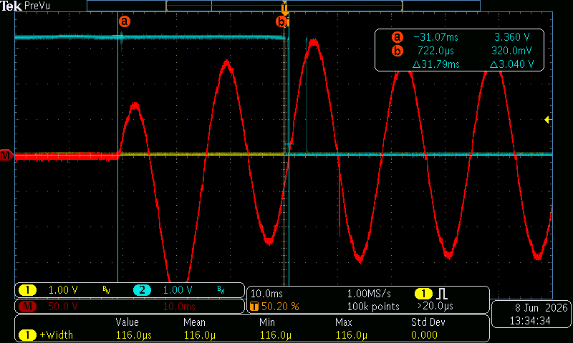

Wide-span view of power loss, power loss detection, power loss query, and flash writes. Note that blue signal is already high at the start because one write had been performed in a preceding cycle which produced a lockout.

Image:
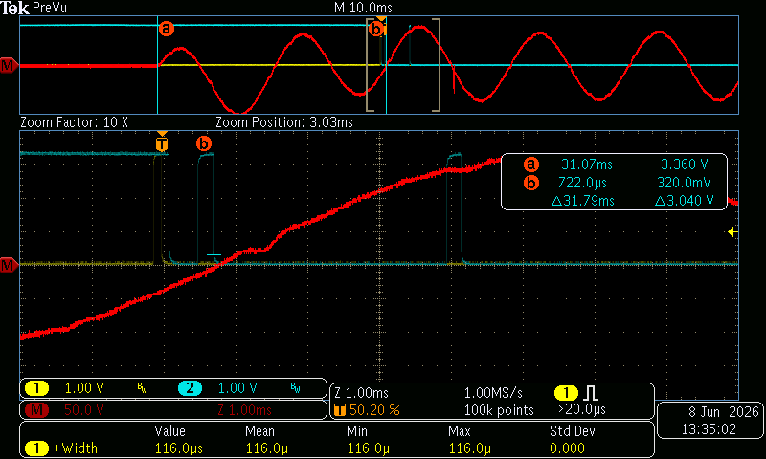

Close-in view of the timing of power loss detection, power loss query, and flash writes.

Comments: during testing, a bug was discovered that caused the controller to write two extra times during the power off sequence, so time was only measured until the third pulse. This bug has been noted, will be fixed in a future version. This does not affect any timing tests. See GitLab issue #716.

Time from Power Loss Detection to Completion of Flash Writes

See 8.14.3 for full details. Value determined by difference between time when the yellow signal went high and the final transition of the blue signal (marked with cursor ⓑ).

Commit: 213f9124

Pipeline: #5409

Time from Cycle Abort to Completion of Flash Writes

See 8.14.3 for details. Time determined from position (relative to trigger) for the final flash write.

Commit: 213f9124

Pipeline: #5409

Main Loop Time

Yellow signal pulsed during a subset of main loops. Display set to infinite-persist mode, and minimum, maximum, and median times measured.

Because the main loop time spreads over a range of average time clusters, in order to present a useful image in infinite-persistence, code had to be modified so that only one main loop would ever be drawn on-screen. To this end, rather than toggle the yellow signal each time through the main loop (as had been done in previous versions of this test), the yellow signal was pulsed for the duration of every 17th main loop. This provided a significant enough delay that, after triggering a draw cycle in one loop, no subsequent loop would ever pulse again before beam reached the right side of the display and reset. The number 17 was chosen because it was unlikely that any pattern in timing would repeat on intervals of 17, so any particular “kind” of cycle would likely show up as regularly as any other.

Commit: e7c2296d

Pipeline: #5377

Image:
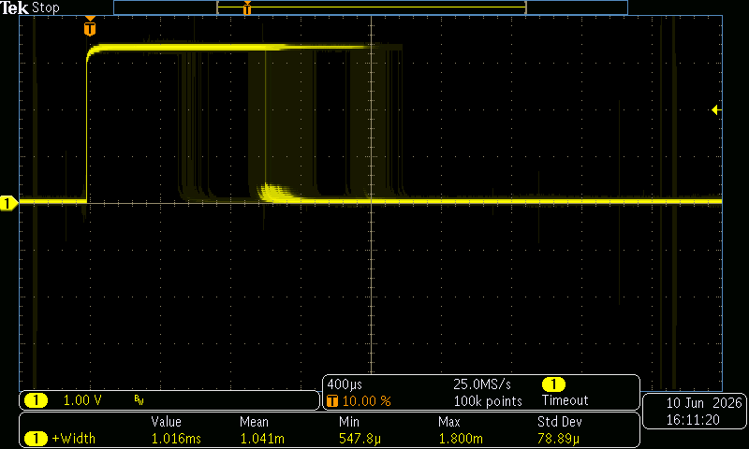

Infinite-persist capture of main loop, after letting the device sit in Standby for 10 minutes and then taking it through several run cycles.

Image:
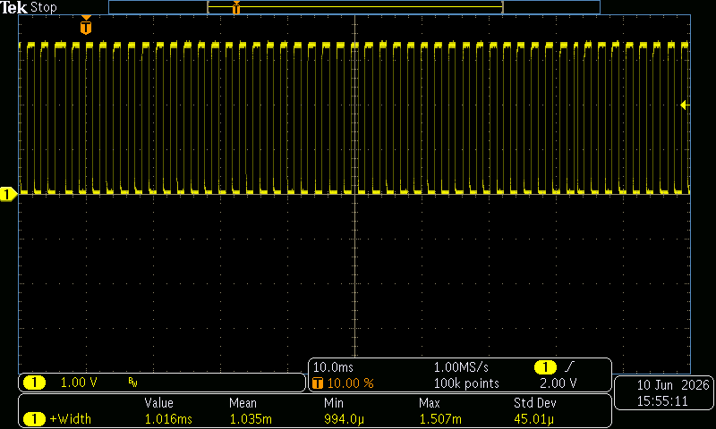

Captured with commit 1c963480 (pipeline #5428) while running in Standby mode.

Comments: As seen in image 8.14.6.6, in Standby mode the main loop is consistent in duration, with no long delays from interrupts or function calls.

Maintain Safety Time

Yellow signal pulsed around call to MaintainSafety(), pulse width measured.

Commit: 0161deb4d

Pipeline: #5348

CRC-32 Full Check

Yellow signal toggled on entry to function STL_FlashCrc32Init(), pulse width measured.

Commit: d9001acdb

Pipeline: #5349

Comments: Every time MaintainSafety() is called, a portion of computing a CRC-32 checksum of firmware code is performed. STL_FlashCrc32Init() is called each time a new full checksum is computed, so this test doesn’t record the amount of processor time spent computing a CRC-32 checksum, but instead how long it takes to call MaintainSafety() enough times to do a full checksum computation.

Serial Comms (Get Advertisement Data)

Yellow signal pulsed around serial message-handling code while not connected with myTechnician. Pulse width measured.

Commit: 1b2bd8269

Pipeline: #5350

SysTick Interrupt

Yellow signal pulsed during handling of SysTick interrupt, pulse width and frequency measured.

Commit: 31366111c

Pipeline: #5352

ADC1 Interrupt, Single Sample Completed

Yellow signal pulsed during handling of ADC1 interrupt when EOC flag is active, pulse width measured.

Commit: 8f30adb3

Pipeline: #5353

Image:
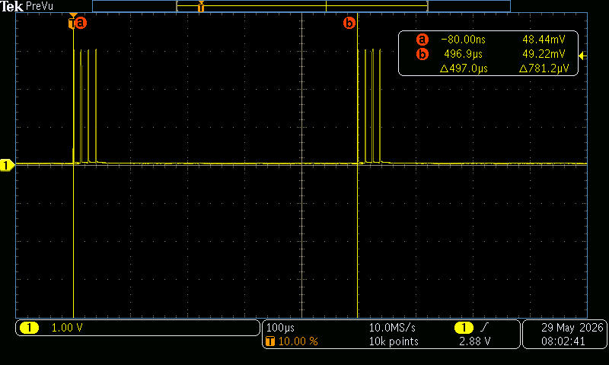

Comments: This code fires in bursts of four. Each burst occurs at ~2kHz, and interrupt fires at ~77kHz within each burst. The interrupt reads four separate analog values, from four different channels, and fires the interrupt once for each channel when a datapoint is available. The line voltage, CPU temperature, internal reference voltage, and line current are taken. An ADC burst is triggered from TIM17, which fires at a regular 2kHz, and so the bursts occur at 2kHz. The final interrupt in each burst both reads the four values and performs final processing of the four values recorded from the whole burst, so the final interrupt duration is usually slightly longer.

ADC1 Interrupt, Time from First Sample to Sampling Completion

Yellow signal raised at start of handler when a single conversion is complete and cleared when handling of a group of samples is completed. Pulse width measured across the screen.

Commit: f8e70d9c

Pipeline: #5354

Image:
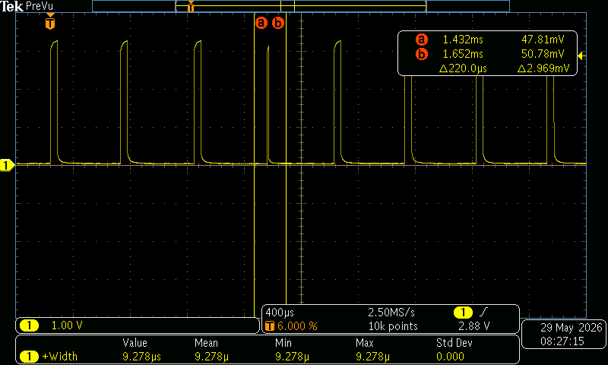

Comments: Pulses are generally ~47μs in duration, but occasionally ~3.1μs instead. This is caused by the ADC occasionally having an overrun, which causes the fourth interrupt in each burst to skip final processing.

ADC1 Interrupt, Scan Complete

Yellow signal pulsed during handling of completed group of samples, pulse width measured.

Commit: c051ee0c

Pipeline: #5355

Image:
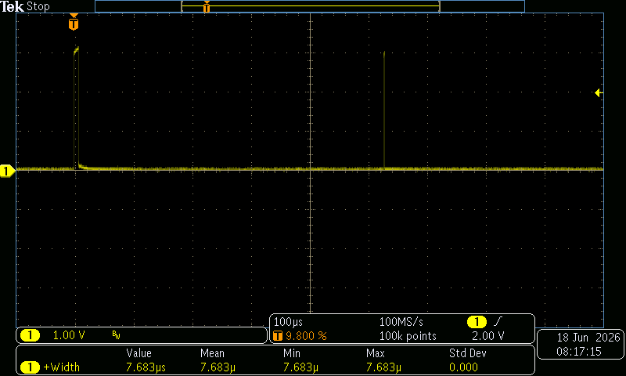

Comments: As explained in 8.14.12.5, the final processing which takes place in a burst of ADC readings is occasionally skipped entirely; this is shown every so often by a small ~1 microsecond burst.

ADC1, Whole Interrupt

Yellow signal pulsed during entirety of ADC1 interrupt handler. Period(∆), pulse area, and average high level measured during single burst of 4 interrupts; period of bursts measured manually. Measurements recorded 10 runs individually. (Measurements for period must be taken on a different time scale as area and high for a more accurate reading)

Commit: b6c6dd7f

Pipeline: #5356

Image:

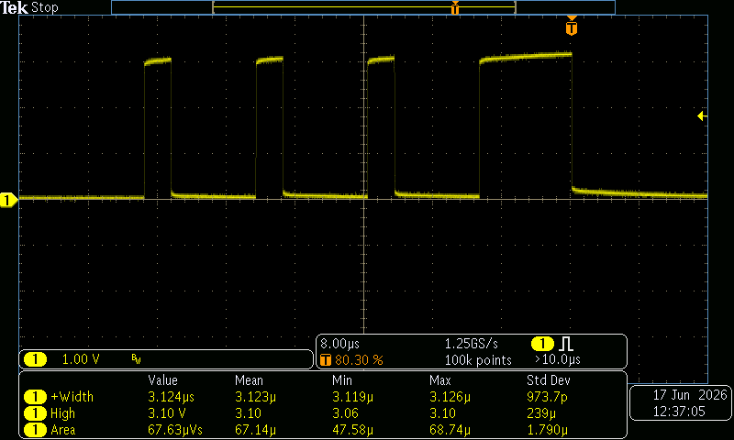

Trigger set to pulse width after 10 microseconds to trigger consistently after the last interrupt fires. This allows for the largest render of a single burst while still fitting in the scope.

Image:

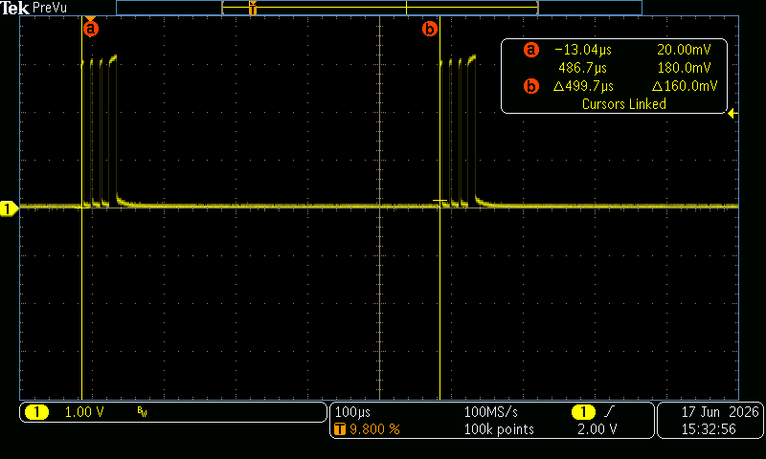

This shows how period of bursts is measured. Cursor ⓐ is inclusive of the left burst and cursor ⓑ is exclusive of the right burst.

Percent total processor time (duty cycle) computed by taking the “Area” measurement reported by the oscilloscope (in unit Volt-Seconds) and dividing by the Period multiplied by the “High” measurement reported by the Oscilloscope (the product of those two is also in Volt-Seconds).

TIM17 Interrupt

Yellow signal pulsed during handling of TIM17 interrupt, pulse width and frequency measured. The test was conducted and measured for both Standby and Run states. The results suggest minimal variation in pulse width between the two states, indicating consistent interrupt behavior.

Commit: 4107e792

Pipeline: #5357

Comments: TIM17 fires at ~2kHz intervals and reads inputs for AC signals and triggers a round of ADC sampling.

TIM16 Interrupt

Yellow signal pulsed during handling of TIM16 interrupt, pulse width measured. Blue signal was toggled during handling of TIM16 interrupt to measure half frequency/period.

Commit: 2ddbf648

Pipeline: #5358

Comments: TIM16 is responsible for determining end of serial transmission by timing out when no USART2 interrupts have occurred for some time. Since serial messages are normally sent by the IoT card on a 10Hz basis, this interrupt typically fires at 10Hz.

USART2 Interrupt

Yellow signal pulsed during handling of USART2 interrupt, pulse width measured to determine duration of individual interrupts. Area of a burst and average high level were measured for individual pulses. Cursors used to measure period of bursts over 10 measurements.

Measurement of period must be taken with separate acquisition timescale, as the burst period and interrupt duration differ by 5 orders of magnitude. This also means that area can only be measured properly over one pulse. It must be multiplied by 25 to reflect the entire burst.

Commit: 1e0ea204

Pipeline: #5360

Image:
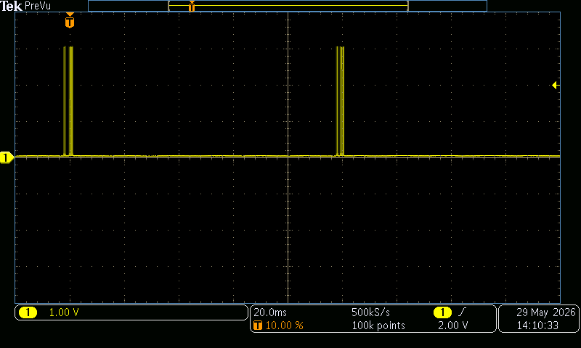

This shows two bursts of this interrupt firing.

Image:
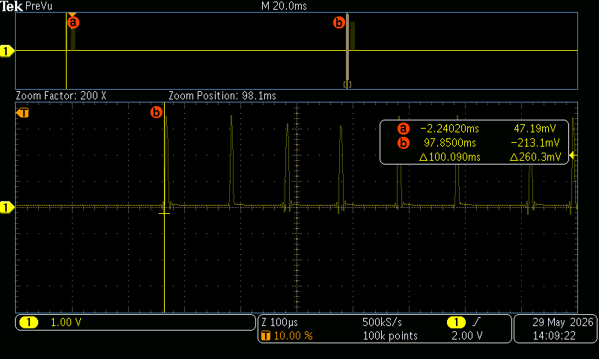

A close-up of the second burst in the above capture (sampling resolution at this zoomed-in scale is fairly low). This shows how the far end of the gating window is set just before the second burst, as the separation between the two cursors measures the burst period.

Image:
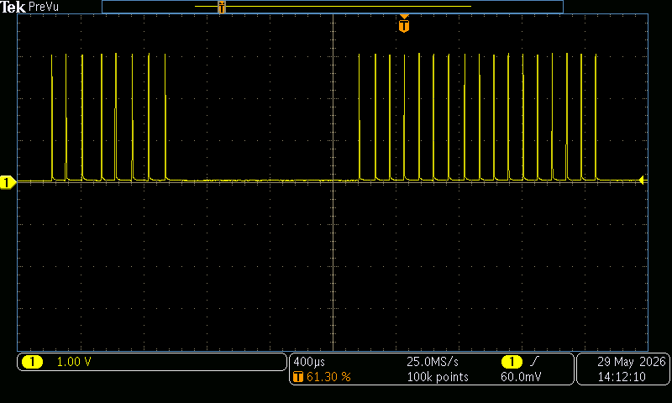

The same sort of burst as before, but with the acquisition timescale drastically reduced to increase the resolution. This shows that the interrupt fires in bursts of 25; first 8 and then 17, which matches up with the expected line protocol for Modbus over serial lines requesting presence data and advertisement data; the interrupt fires once for each byte transferred.

Image:
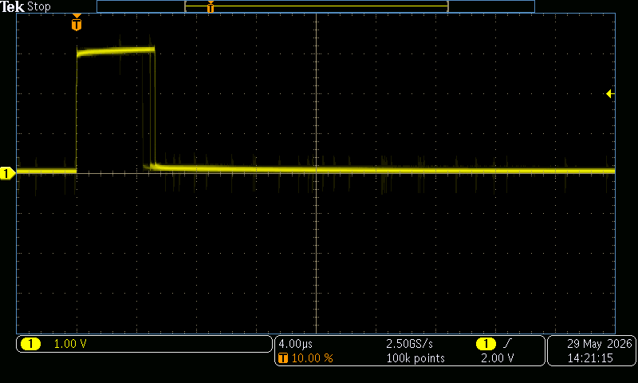

Infinite-persist image of USART2 interrupt handler duration.

Comments: This interrupt fires when serial messages are being sent or received. For each message, this usually results in this interrupt firing multiple times. Since the IoT card normally communicates at 10Hz to perform status checks, this interrupt fires in bursts, with a 10Hz frequency from burst-to-burst. The timing of interrupts within a burst is somewhat more variable, as is the number of interrupts within a burst. Lastly, there is also a small gap within bursts separating request bytes from response bytes; the duration of this gap is also variable.

TIM1 Interrupt

Yellow signal pulsed during handling of TIM1 interrupt, pulse width measured. Action button pressed repeatedly during data-gathering.

Commit: 73b495a4

Pipeline: #5361

Comments: TIM1 is the interrupt for the Advanced-Control Timer, which in this codebase is used for checking for action-button presses and debouncing the signal from the action button.

I²C interrupt

Yellow signal pulsed high in RunAccelerometerStateMachine() around the case ACCEL_READ_NUM_UNREAD. Blue signal was toggled around the I²C interrupt handler. This allows for three things to be able to be measured in the same commit; I²C Interrupt duration, duty cycle of the I²C inside of the ACCEL_READ_NUM_UNREAD, and the duty cycle of the I²C inside of the ACCEL_READ_SAMPLES.

Commit: 834a8576

Pipeline: #5412

To get the interrupt duration the trigger was set to pulse on the blue pulse’s rising edge to measure blue’s pulse width, 10 individual measurements were taken for each pulse in the burst as the trigger pulse did not vary in duration as much as the later pulses did.

Image:

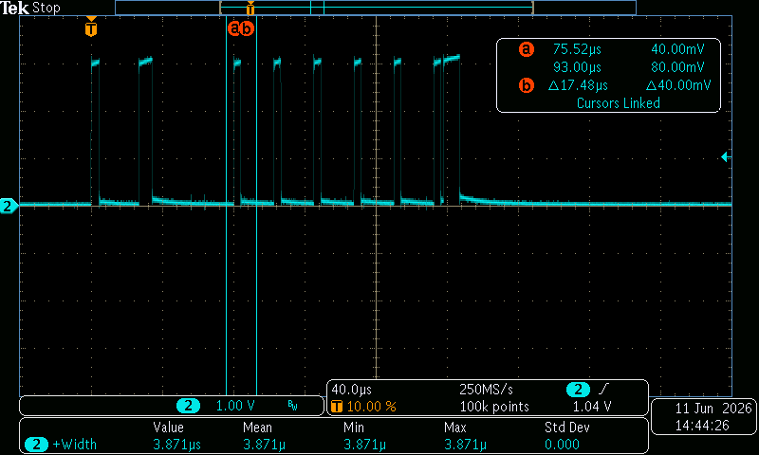

Comments: The pulsing of the I²C interrupt always followed a very specific pattern, the first pulse being ~4.5 µs, the second being ~7.4 µs, the final pulse being ~9.05 µs, and all center pulses ~3.87 µs for simple byte transfers.

To get the percent duty cycle of the I²C interrupts inside of the ACCEL_READ_NUM_UNREAD case. Both yellow and blue Areas were measured using the cursor. Later the duty cycle could be calculated by dividing the inner area by the outer area. Measurements were taken over 32 pulses.

Image:
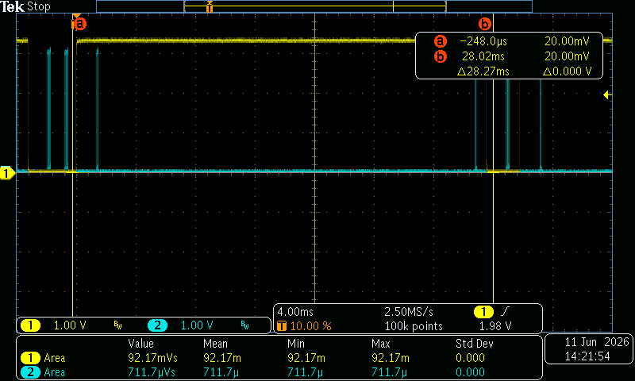

Yellow positive pulse shows the time inside of the ACCEL_READ_NUM_UNREAD state, with cursors set to just outside of the outside edge.

To get the percent duty cycle of the I²C interrupts inside of the ACCEL_READ_SAMPLES case. Oscilloscope was set to be triggered on the falling edge of yellow signal and cursors were placed before and after the negative pulse. The blue signal’s area, and the yellow signal’s negative pulse width and high were measured over 32 pulses. Duty cycle was calculated by dividing the inner area (blue signal’s width) by the outer area (yellow signal’s high multiplies by its width).

Image:
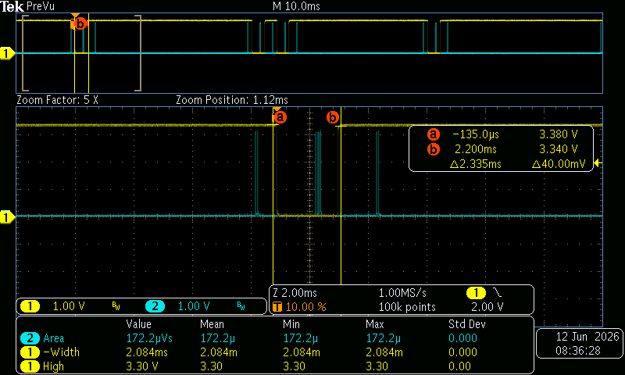

Close up view of the cursors around the negative pulse for the ACCEL_READ_SAMPLES case.

Comments: Since the oscilloscope does not have an easy way to track the area of a negative pulse, it needs to be found by using the pulses width and the Hight.

I²C Overall Duty Cycle

The Yellow signal pulsed before and after the I²C interrupt fires. The blue signal was pulsed before the interrupt first fired and cleared at the start of the next burst, letting the blue burst represent the total period. Sample size was set to 500 and area was measured for both blue and yellow pulses. Later the percent processor time could be calculated by diving the pulse area of the yellow signal by the pulse area of the blue signal, as it describes what percent the I²C interrupt is high relative to the rest of the controllers execution time.

Commit: d70c46ad

Pipeline: #5404

Image:
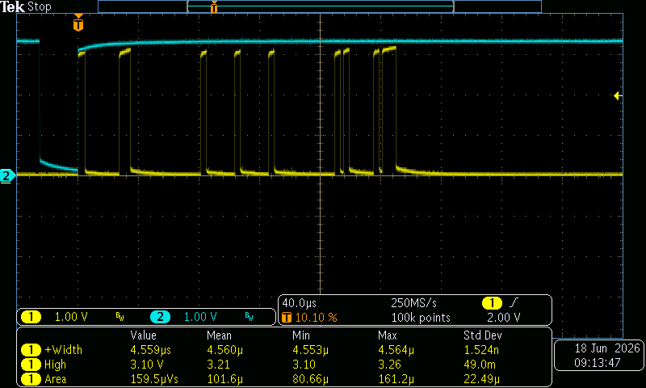

The blue pulse begins directly before the first interrupt in the burst fires but clears ~25 µs before the next one burst begins. This is caused by a 25 µs delay between the controller sending a message to the $I^{2}C$ and it is writing one back to tell an interrupt to fire.

Image:
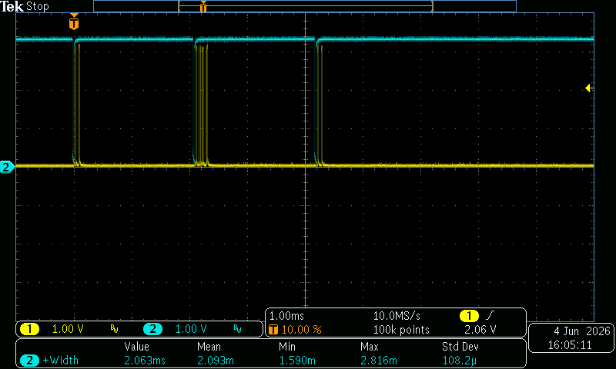

The blue pulse begins directly before the first interrupt in the burst fires but clears ~25 µs before the next one burst begins. This is caused by a 25 µs delay between the controller sending a message to the I²C and it writing one back.

Flash Check

Yellow signal pulsed around call to FlashCheck() within firmware initialization, pulse width measured. Triggered on pulse width >3ms, to ignore noise caused by closing power switch. Times recorded individually over 10 runs.

Commit: 293944e5

Pipeline: #5362

Time from Firmware Start, to First WDT Reset in Firmware

Yellow signal raised right before bootloader transfers control to firmware, then cleared after call to ResetWatchdog() in function MaintainSafety(); after that, it enters infinite loop to ensure WDT is triggered, causing an automatic reset. This allows multiple sequential measurements to be made quickly so that the oscilloscope can gather statistical data, without having to deal with noise caused by opening and closing of the power switch.

Commit: 92c2a38d

Pipeline: #5363

Time from Bootloader WDT Start to Bootloader WDT Reset

Yellow signal raised when bootloader starts WDT, reset when WDT is cleared right before jumping to firmware, measurement gate set manually using cursors to the second large yellow pulse, yellow pulse width measured. Times recorded individually over 10 runs.

Commit: 0143d3bb

Pipeline: #5378

Image:
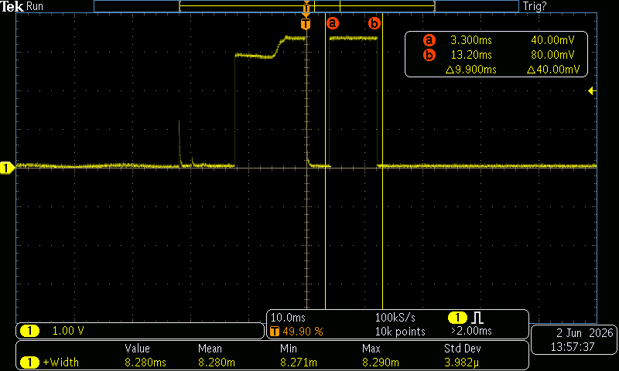

This shows the spike of noise, and the times from the two runs of the bootloader during normal startup. It is the second run that is of interest.

Comments: Two difficulties presented themselves in measuring this. The first is that turning the controller on creates a spike in the yellow signal, which will trigger a positive-edge trigger. Although a pulse width trigger could be used, the bootloader also happens to run twice on start-up, not once. The first one is used as a test of the watchdog timer itself, and it is the time for the second run which is of interest.

Cylon

Yellow signal pulsed during Cylon code in HandleStatusLights() and cleared after cylonDone variable is set to true, pulse width measured. Resetting of watchdog timer in main loop disabled to deliberately cause watchdog timer to reset after Cylon is done. This allows multiple sequential measurements to be made quickly so that the oscilloscope can gather statistical data, without having to deal with noise caused by opening and closing of the power switch.

Commit: aa0d773d

Pipeline: #5365

Comments: Cylon is called once per main loop and does not block main execution. The total time is less than 1 second which meets the requirements of ES-0175, Rev.b, dated 6/11/2026

Power-On to Entering Standby

Yellow signal raised in the first-time handler for DoStandby(). Time between this and power-on recorded manually for 10 runs.

Commit: 4afb9eef

Pipeline: # 5367

Image:

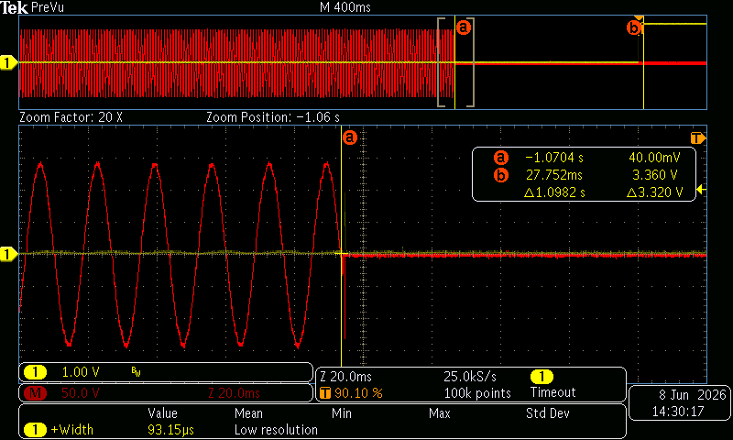

This shows a zoom of the power flowing into the controller and the point at which the controller entered Standby mode. Cursor ⓐ was used to measure the time between power loss and the trigger.

Time in Reset

Yellow signal raised when entering DoReset() and cleared when entering DoStandby(). Because the oscilloscope runs in moving-graph mode at the horizontal scale required to measure this, the Run/Standby button is operated manually to capture a full yellow pulse. Yellow pulse width measured.

Commit: e868321c

Pipeline: #5366

ADC Calibration

Yellow signal raised when before call to LL_ADC_StartCalibration()and cleared when calibration is finished. Timeout clocked commented out to measure longer possible pulses. Pulse width measured individually for 10 runs.

Commit: 5aae013d

Pipeline: #5411

Field Configuration Write from IoT Card

Yellow signal pulsed during processing of serial messages in HandleSerialComms(); blue signal pulsed within function WriteFieldConfig(). Then the field config lock for maxTfiTries was unlocked to be overwritten during testing. Due to issues with myTechnician, test was conducted by connecting the controller to the serial port and running the python 3.12 script, ChangeFieldConfig.py. This script utilized pyModbus 2.5.3 to connect to the controller, read the field configuration holding registers, and write them back with a different value. Each run, the script was manually edited by changing the number of TFI tries between 1 and 2. Yellow pulse width measured but triggered on blue pulse rising edge. times recorded individually.

Commit: 4714ef2f

Pipeline: #5308

Comments: Previously the process was completed via 10 field configuration writes in myTechnician, by alternating value of number of retries in the app, then writing them to the controller. Since this was not available at the time of testing, serial port and pyModbus were utilized in its place. This had no effect on the timing and are interchangeable processes. Refer to ES-0176, Rev b for register memory locations and sizes.

Field Configuration Read from IoT Card

Yellow signal pulsed during processing of serial messages in main loop; blue signal raised when entering function HoldingReadFieldConfig() and cleared at the same time yellow signal is cleared (pulse would be too short to be useful otherwise). Yellow pulse width measured but triggered on blue pulse rising edge. 10 field configurations were read individually through nRF Connect in the Primary Service section, 64121005, with the vendor UUID, 64122102 while connected to the DUT.

Commit: afb6907bd

Pipeline: #5368

Comments: Previously the process was completed by reading 10 field configurations from myTechnician, nRF connect was used in replacement. This had no effect on the timing. Refer to ES-0178 Rev b, dated 5/4/2026 - Section 4.4.2 for characteristics and UUID.

Maximum Modbus Timing (Gather Report Data)

Yellow signal pulsed during a subset of serial processing inside main loop. Oscilloscope set to infinite-persist mode, with a maximum screen width of 1ms (100μs per division) and the DUT connected to the serial adapter. Similar to 8.14.30 the python3 script MaximumModbus.py was written to emulate a myTechnician service report and would read all important registers at the same speed. 64 runs of the script were individually executed, and the maximum pulse widths of the yellow signal was measured. MaximumModbusOutput.txt can be referenced to see the registers were successfully read.

The time between yellow signal pulses is occasionally very small, smaller than the maximum duration of the pulse. Getting only a single pulse on screen proved troublesome using strategies similar to those employed in 8.14.6; eventually the code was modified to check the value of the uwTick variable incremented by the SysTick interrupt (which happens every 1ms) and only pulsing if the value of the variable had changed since the last time the signal was pulsed; this worked satisfactorily.

Commit: bbd89349

Pipeline: #5382

Image:
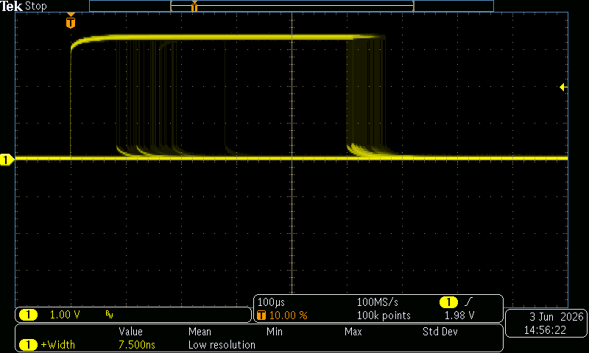

10-minute infinite persist measurement.

Read WhoAmI

Yellow signal raised in GetAccelerometerSamples()state machine when next is set to the case ACCEL_READ_WHOAMI and cleared when changing case again. Pulse width measured individually for 10 runs.

Commit: adfc597b

Pipeline: #5394

Write Configuration

Yellow signal raised in GetAccelerometerSamples()state machine when next is set to the case ACCEL_WRITE_CONFIGURATION and cleared when changing case again. Pulse width measured individually for 10 runs.

Commit: c51512ce

Pipeline: #5395

Read Num Unread

Yellow signal raised in GetAccelerometerSamples()state machine when next is set to the case ACCEL_READ_NUM_UNREAD and cleared when leaving. Pulse width of the yellow signal was recorded normally. Following, the sample size on the oscilloscope was raised to 500 measurements for a more accurate reading. Positive duty cycle and pulse width were recorded.

Commit: 83fa41b5

Pipeline: #5396

Image:
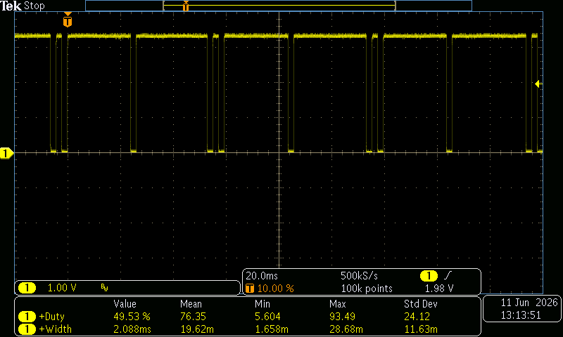

Comments: As seen, the pulses commonly have 2 varied sizes with no set average so only the maximum and minimum pulse widths were recorded. Given the states change between ACCEL_READ_NUM_UNREAD and ACCEL_READ_SAMPLES the oscilloscope can be set to capture both positive duty cycle for this test and negative duty cycle for 8.14.36.

Read Samples

Yellow signal raised in GetAccelerometerSamples()state machine when next is set to the case ACCEL_READ_SAMPLES and cleared when leaving. Yellow pulse width was recorded. Following, the sample size on the oscilloscope was raised to 500 measurements for a more accurate reading. Positive duty cycle and pulse width were recorded.

Commit: e0c5aa12

Pipeline: #5397

Image:
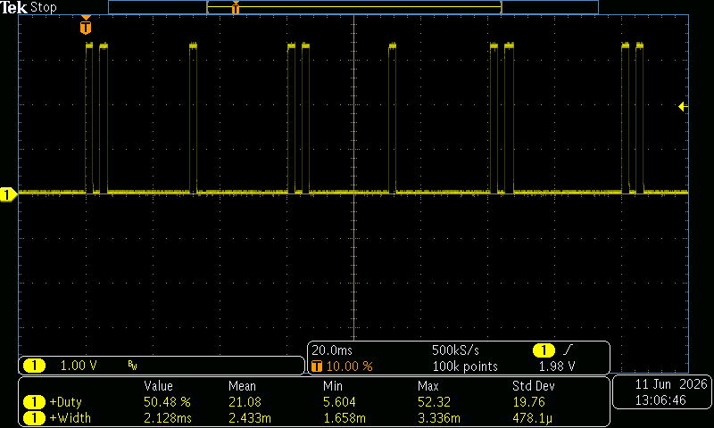

Comments: duration and duty cycle of ACCEL_READ_SAMPLES case

Bootloader Main Loop

Yellow signal toggled at start of bootloader main loop. A reasonably long capture was taken, and the first 16 pulse widths (both positive and negative) measured individually. Oscilloscope measured the widths, but the measurement intervals were set manually 16 times.

Commit: 96fa2659

Pipeline: #5368

Image:
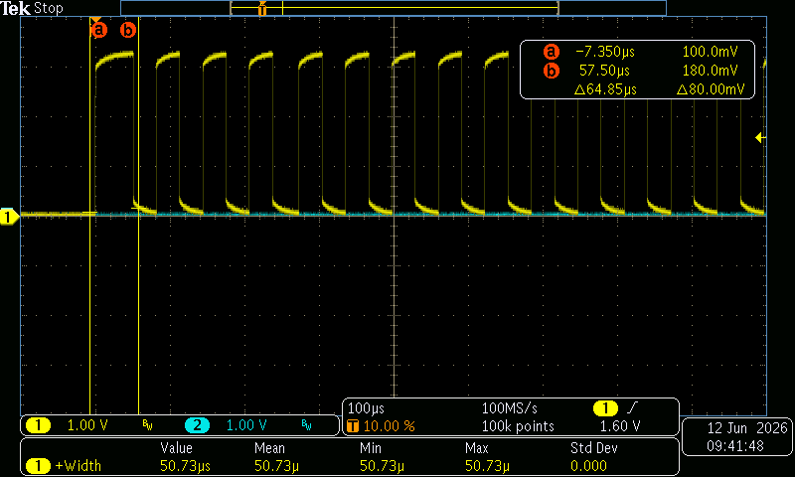

Comments: The first run through the main loop consistently takes 50μs compared to the nearly exactly 31μs taken by all subsequent loops.

TIM17 Interrupt Disabling — HandleAC_Inputs()

In the function HandleAC_Inputs(), two function calls demarcate a boundary in the code where the TIM17 interrupt is disabled. Yellow signal is pulsed just inside this boundary, and blue signal is pulsed just outside of it. Triggered on yellow pulse, yellow and blue pulse widths both measured.

Commit: ff8354a1

Pipeline: #5383

Image:
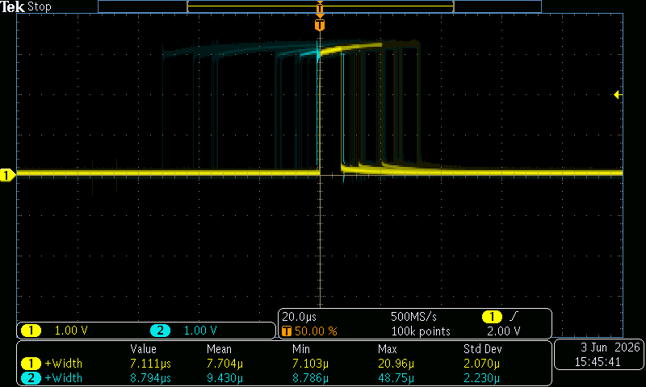

10-minute capture taken with infinite-persist enabled.

Flame Sensing State Timings

This test was aimed at evaluating how fast the controller switches between charging and discharging the Flame Sensing Capacitor. Blue pulse width shows the time spent discharging (or “crashing”) the Flame-Sense capacitor, while the yellow pulse width shows the time spent waiting for it to charge to a threshold voltage.

Commit: 2aabe9ea

Pipeline: #5371

Image:

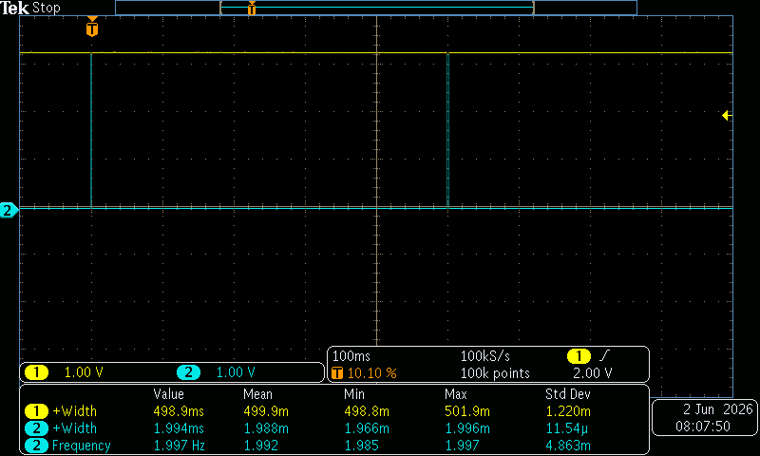

This capture was taken while the Flame on the Demo box was set to ‘OFF’.

Image

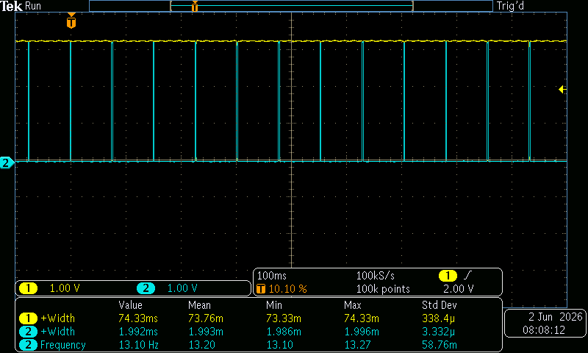

This image was captured while the Flame on the Demo Box was set to ‘ON’.

TIM17 Interrupt Disabling — HandleLinePower()

In the function HandleLinePower(), two function calls demarcate a boundary in the code where the TIM17 interrupt is disabled. Yellow signal is pulsed just inside this boundary, and blue signal is pulsed just outside of it. Triggered on yellow pulse, yellow and blue pulse widths both measured.

Commit: a7bd9325

Pipeline: #5372

MotorChargeCap()

Yellow signal pulsed within function MotorChargeCap(); blue signal toggled on entry to this function. Unit was repeatedly, manually put into a run state; before beginning each run, the current state of the blue signal was noted, and the oscilloscope was configured to trigger when the blue signal changed to the opposite state but did not change back within 1ms; yellow pulse width measured. This unusual triggering configuration is required by the noise created in the blue signal when closing T-T and LIMIT switches. Times recorded individually over 32 runs.

Commit: 113bfae4

Pipeline: #5373

Comments: Using the Timeout trigger type make sure to change the polarity of the wave according to what state the blue wave is in.

Safety Relay On to Motor Relay On

Yellow signal raised when safety relay activated; and cleared when motor is relay activated. Yellow signal is activated again when the motor relay is deactivated and cleared when the safety relay is deactivated. Triggered on yellow pulse width >500μs, pulse width measured. Times recorded individually over 10 runs for both conditions where the Motor is ON and OFF.

Commit: d440bec8

Pipeline: #5375

Image:

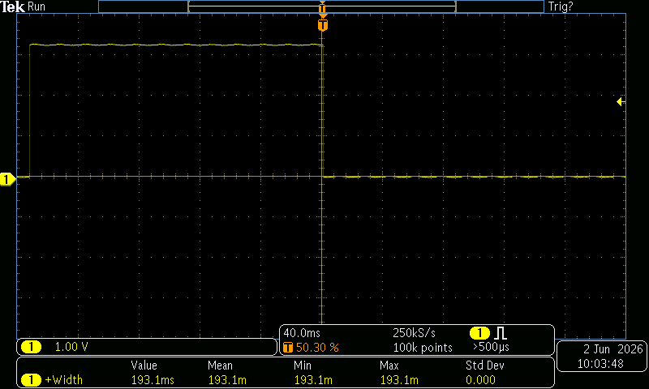

The image shows the time between Safety Relay turn-on and Motor Relay turn-on.

Image:

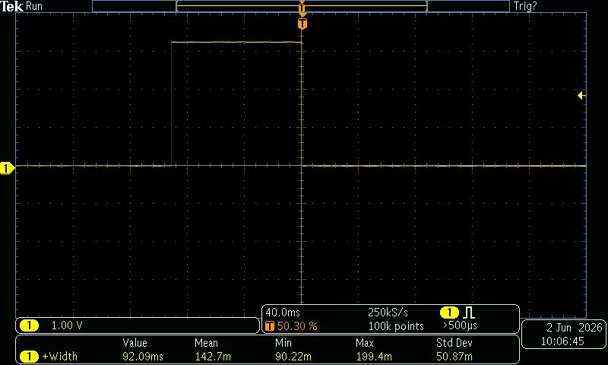

The image shows the time between Motor Relay shut-off to Safety Relay shut-off.

Flash Page Erasure

Blue signal pulsed within HandleFlashStackErasure(), when it does not return early; yellow signal toggled within main loop. Triggered on blue pulse width >4ms; blue pulse width measured, and yellow pulse width (high or low, as appropriate) measured. Field safeDeleteIndex of Field Configuration Number of Retries set to 1. Each run created by writing a new field configuration using the technique in 8.14.30 and the same ChangeFieldConfig.py file. Times recorded individually over 10 runs. Blue pulse width indicates time spent erasing a flash page; yellow pulse width indicates duration of a main-loop in which a flash page erasure occurs. Blue pulse width recorded in summary table.

Commit: f160a7ce

Pipeline: #5381

Image:

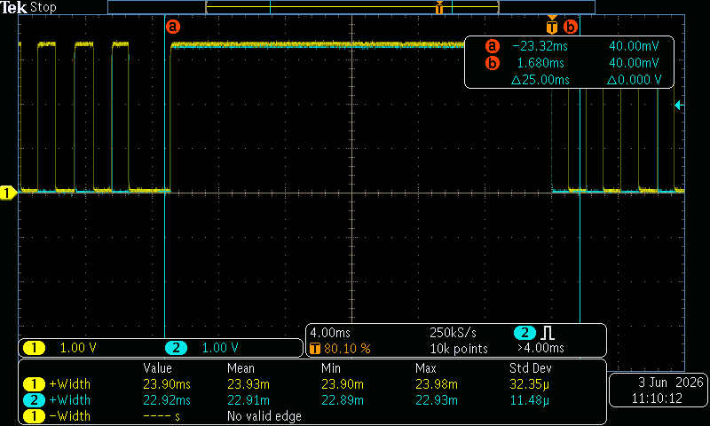

Capture shows the ~24ms main loop iteration during which a flash page was erased, followed by numerous much shorter main loop iterations.

Bootloader Firmware Flash Erasure

Yellow signal pulsed around bootloader code which erases all pages of firmware from flash memory, pulse width measured. Triggered on pulse width >100ms, to ignore noise caused by closing power switch. Flashed with firmware from below commit and then repeatedly OTA-updated with the same image using the serial IoT adapter. Times recorded individually from 10 runs.

Commit: ef9612e0

Pipeline: #5376

Bootloader OTA Block Writing

Blue signal pulsed around call to WriteOtaBlock() within bootloader, blue pulse width measured. Statistics gathered from a single firmware update, which should have called this function 410 times.

Commit: ef9612e0 (same as 8.14.44)

Pipeline: #5376 (same as 8.14.44)

Image:
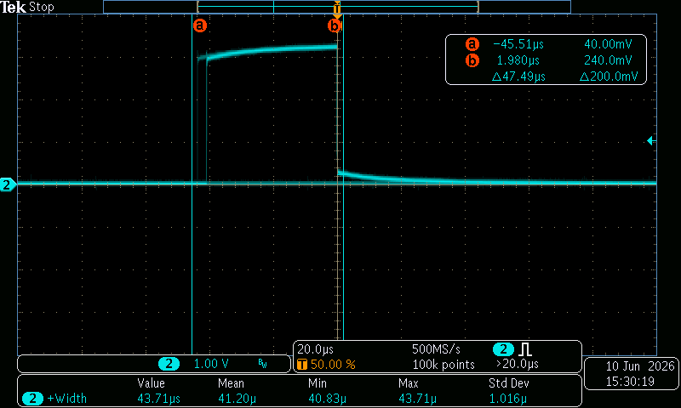

Infinite-persist image of write times.

Comments: Cursors were used on edges of pulse to ignore unintended noise.

Test Equipment

Programming Tools
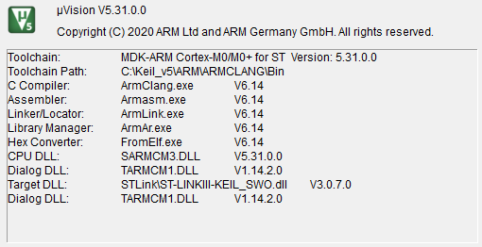

Note that Keil µVision itself was not used, this only indicates the version numbers for the binary tools.

Controller Programming

Hardware: 3.3V USB-to-Serial adapter: FTDI TTL-232RG-VSW3V3-WE

Modification assembled with USB Full-A Male plug on serial end, connected like the corresponding plug on a 7653 IoT Card.

Software: “QuickFlashing” scripts distributed in "S:\Engineering\Facilities-Equipment-Tools\Software Tools\RWB\QuickFlashing"

IoT Adapter Card, version 1

Remote Interaction

Hardware: Samsung Galaxy S20 FE 5G

Model Number: SM-G781V

Serial Number: RFCR20D78QR

Operating System: Android 13

Software: nRF Connect for Mobile

Version: 4.29.1

Input actuation: R.W. Beckett 7595 Demonstrator Box #2

RMS A/C Voltage Measurement: Keysight U1242B DMM, Autorange, True RMS, S/N: MY58070027, GMS-3389, ANAB Calib. Date: 02/14/2025

Voltage-over-Time Signal Measurement: Tektronix MDO3034 Oscilloscope, 350 MHz, S/N: C035846, GMS-4361, A2LA Calib. Date: 07/22/2024

Probe: 4× Tektronix TPP0500B

Line Isolation: Stancor GIS-500 Line Isolator; Input: 115 Vac 50/60 Hz; Output: 115 Vac 500 VA 4.35A; GMS-4821

AC Power Supply: Staco Energy 3PN1010B Variac, Output: 0 to 140 Vac, 10 A, 1.4 kVA, 50/60 Hz; GMS-3957

Detailed Information and Modifications to Device Tested

Two 7595 Primary Control units

Initial 7595 used was a hand-built control in any test not specifying the other was used. Replaced after unknown trace caused relay check errors during 8.14.1, (Power Loss to Loss Detection)

Identification: rev. x, marked with 2 on transformer T1

Software Revision:

Test Branch Tag: testing/20260528-routine-timing

This test uses multiple commits on this branch. Each individual test has the SHA checksum noted of the commit used to run that individual test.

Hardware Revision: x, conformal-coated

Modifications to assembly: See section 8.2

Replacement was a GPV built 7595 controller used for 8.14.1 - 8.14.5 (Power Loss Tests), 8.14.19 - 8.14.22 (I²C Interrupt Testing), 8.14.27 (Power-On to Entering Standby), 8.14.29(ADC calibration), and 8.14.33 - 8.14.36 (accelerometer State Timings).

S/N: 52688-002-A-2622-00071

Software Revision:

Test Branch Tag: testing/20260528-routine-timing

This test uses multiple commits on this branch. Each individual test has the SHA checksum noted of the commit used to run that individual test.

Hardware Revision: x, conformal-coated.

Modifications to assembly: See section 8.2

Two GPV-built 7653 IoT Card

Used together with initial GeniSys from 10.1.1

Model Number: 7653A 0001

Serial Number: 231128 10003604 01007

Firmware Version: v2.0.1287

Hardware Revision: B

Used together with secondary GeniSys from 10.1.2

Model Number: 7653A 0001

Serial Number: 260526 10003604 00186

Firmware Version: v2.0.5392

Hardware Revision: C

